**Website proposal For Tourism website in northern Areas Of Pakistan.**

The purpose of this website is to develop a valuable set of information sources that provides travelers with information and news about Pakistan Northern areas. Our website will also serve as a social environment that allows for travelers to discuss and chat about travel related topics.

Property/parks information for places will also be display on website by information provided by Galiat Development authority (GDA)

**Website Requirements**

•  PHP programed and English language website

•  Linked to our Pakistan booking site and Hotels (In Northern Areas) for online sales

•  Comprise destinations and attractions, we can use the Ayubia, Nathiagali, Murree pictures and information  that we already have

•  Comprise of travel blogs or write-ups by some of our sponsored Media

•  Will contain some local news or local press releases

•  Will feature articles on lifestyle consistent with our brand positioning

•  Engage social media (facebook , twitter)

•  Occasional tie-ups with national Tourism Boards and GDA

•  A section on key corporate news

**Website Structure &Design:**

Proposed Site Map

The following site map is proposed. The site map may change during the development of the

website.

Home Page – including an introduction, booking module, subscriber sign up form, related news,

promotions and social modules

Article Pages – up to 10 Search Engine optimized article pages providing information to visitors

searching the web looking for information on your firm, tourism or Pakistan travel

A Web-blog (Blog) page for additional information and to assist your SE Optimization efforts

A Newsletter sign up page

A Contact Us page– including your company address, phone, fax, and an online contact form to

minimize spam email messages

A detailed Site Map – an outline of your website to aid both people and Search Engines finding

your web pages

**Proposed Design Elements:**

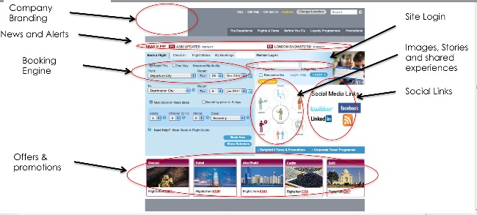

**Site Promotion & Suggested Budget**

We will achieve our campaign goal

by:

a) Increasing brand awareness

b) Connecting with potential consumers

c) Developing a trust relationship with consumers through social engagement

d) Extending commercial relationships with Travel Agents (TAs) through this co-branded micro-site

e) Building awareness of the values you offer to travelers

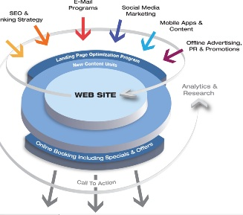

Marketing Budget Components:

Social Media Promotion:

Community Management for site

Affiliate Network/Media

Search Engine Optimization (onpage/offpage):

Search Engine Marketing

**Timeframe & Pricing**

**Website Phases & Timing**

**Phase 1**

•  Proposal review

•  Contract signing

**Phase 2 ( 20 to 30 days) Designing**

•  Decide on and register your domain name

•  Design of site theme, look and feel, template selection, Fonts etc.

•  Development of navigation scheme

•  Additional keyword and competition research

•  Finalization of site map, site layout, and final preparations for construction

•  review and approval from company seniors and possibly with IT Board

**Phase 3 (2 to 3 Months) Development**

•  Receive content and submission of you including your trial home page content, and 5 keyword focused content pages

containing articles for tier two pages, any photographs that you would like to include, affiliate link information for

inclusion in your pages, the name of your new Newsletter and anything else that you would like to include in the site

•  Incorporation of your material into your website including creating your final Sitemap, Newsletter subscription form and

pop up page, Contact Us form and web page, your Web Log (Blog) page, a Links page and the other pages outlined

above

•  Optimize all of these pages for search engine positioning (Baidu/Google) inclusion methods into your website

•  Create and Submit two articles to two of the most appropriate article directories

•  Build links to 5 appropriate websites to start to build Page Rank

•  Test all links, forms and email addresses to make sure that they all work effectively

•  Present your site to you for review and approval

**Phase 4 (1 Month)**

* Content Management System setup and configuration
* S3 Applications Included (news feeds, Booking function, social modules)
* Web Hosting & Statistics (Setup)

**Work Force and time period**

Work force:

Expert and experienced designers: **2**

Expert and experienced Developers: **3**

Internes Or trainees: **8**

Time Period :

With above work force , full project will be complete and Ready to display in **(5 Months)**